ASSIGNMENT 5-B

3-03-2019

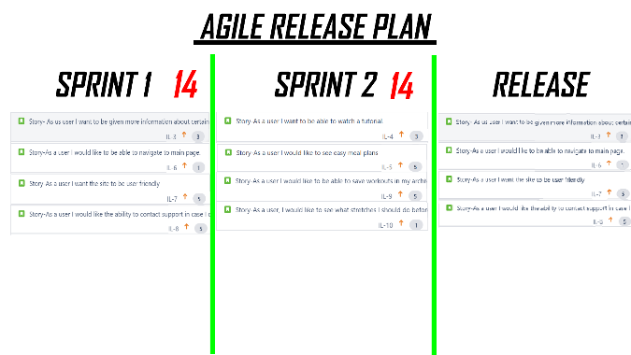**Snapshots of sprint progress**

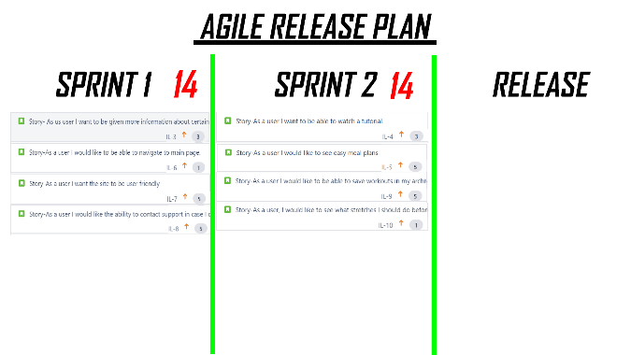

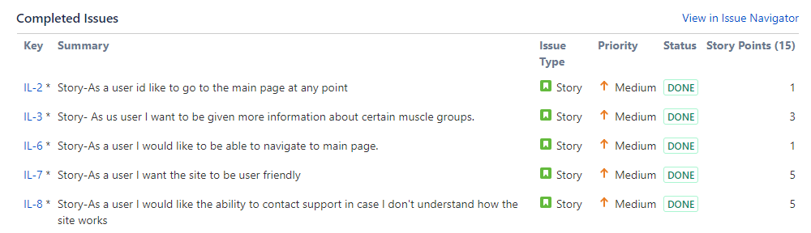

**Burndown chart progress**

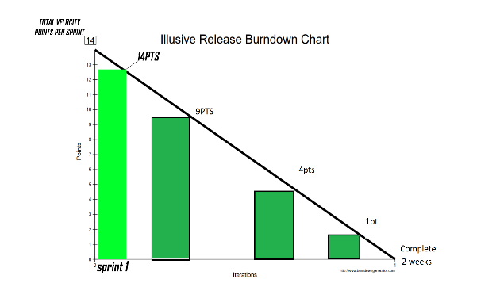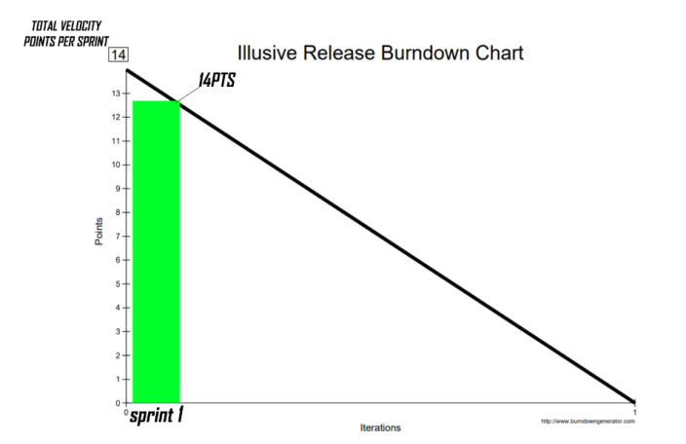

**Issues discussed in stand-ups**

* More involvement from PO regarding user stories
* More 3 CCC’s

**Sprint refinement meeting**

* We held a sprint refinement meeting last Thursday the 27th Feb to discuss if the 1st sprint was completed successfully in regards to the user stories.
* Our PO told us the new user stories he wanted for the next sprint as we prepared for sprint 2.

**Story testing**

* Story testing was very easy to do during our sprint refinement meeting on Thursday as our PO was present and was able to look through the website to see if it was adequate, which it was.

**Code testing**

* An example of the code pulled from github that one of the coders put up for us to test and ensure as a group that it was abiding by the user stories.

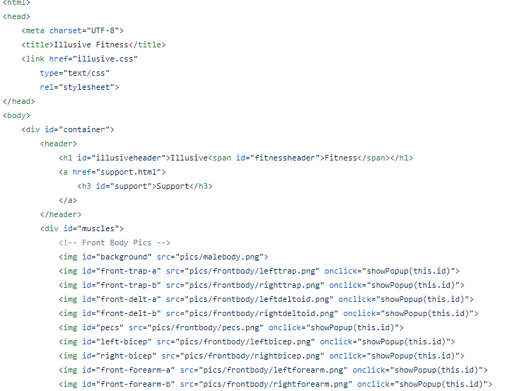

**Sprint 1 user stories status**



**DONE**

**DONE**

**DONE**

**DONE**

**DONE**

* All of the original user stories planned for sprint one were tested and completed.
* The product owner reviewed each of the stories alongside the test website and was satisfied with the results.

**List of user story tasks**

* **Story - IL2 – as a user id like to go to the main page at any point**

1. Completed
2. Owner – Kacper Grzenda

* **Story - IL3 – as a user I want to be given more info on different muscle groups**

1. Completed
2. Owner – Corey O’Donoghue

* **Story - IL7 – As a user i want the site to be user friendly**

1. Completed
2. Owner – Patrick murray

* **As the user I want the ability to be able to contact customer support**

1. Completed
2. Owner – Patrick murray

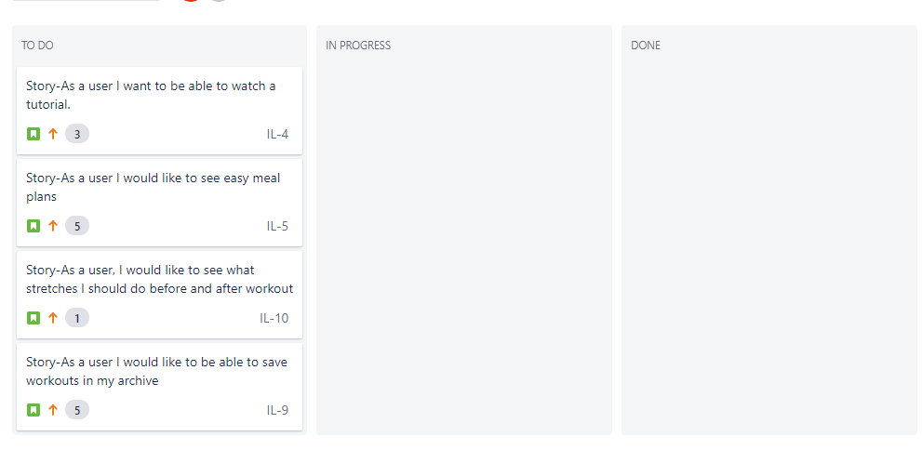

This is our new agile board with 4 new user stories that have been ordered by importance product owner.

**At the End of Sprint 1**

**Story Test plans**

We tested the code by following the tests that were set for each user stories and every user story was reviewed and checked by the tester. When every line of code was tested by the product owner reviewed the finished working user stories and decided if they were acceptable or not.

**Code baseline before sprint begins and after the sprint has finished**

Our website is written in HTML we had no code until the developers started looking at the scrum board and picking out user stories. Once the developers got the user stories they could begin coding and follow the user story directions.

**Show evidence of code and artefact reviews by the team members**

Here is a screenshot of our GitHub where we can all access the code.

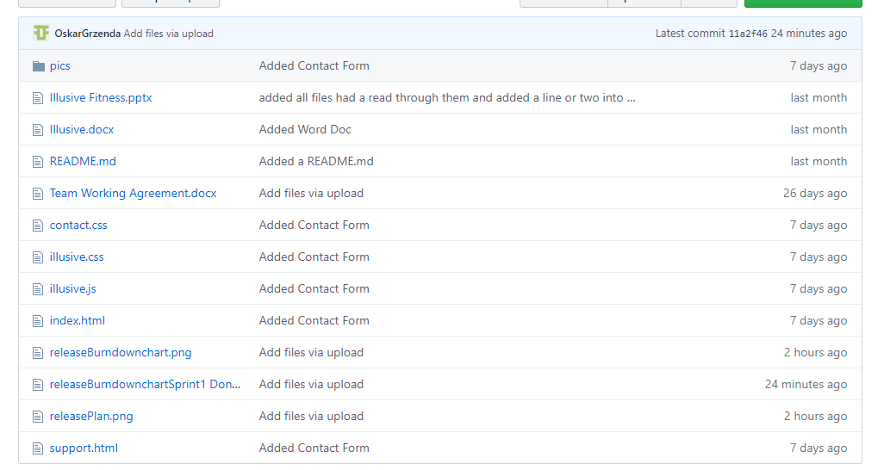

**Updated release plan and release burndown chart after end of sprint 1**

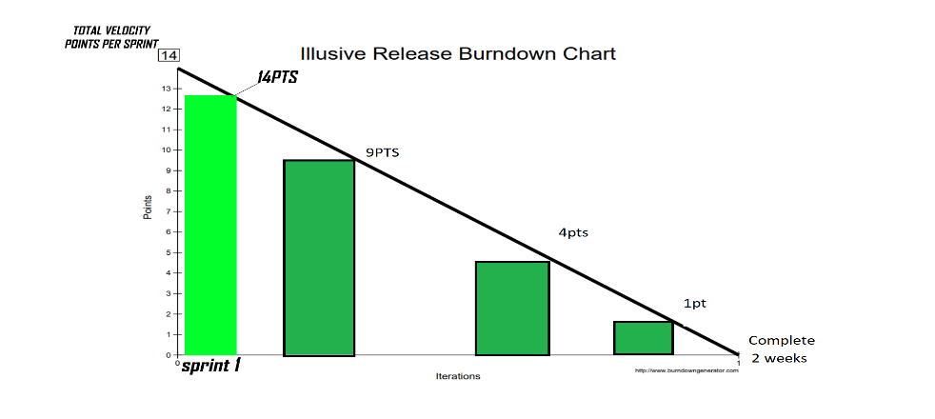

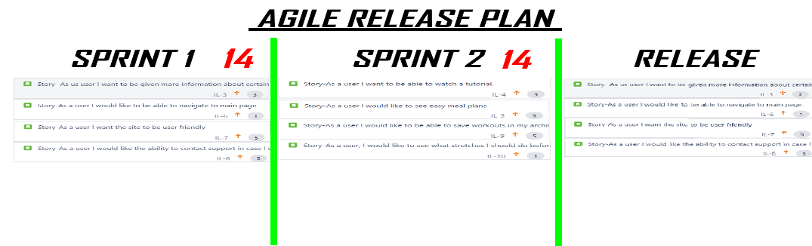

**Sprint 2 Planning**

This is the new release burndown chart for sprint 2

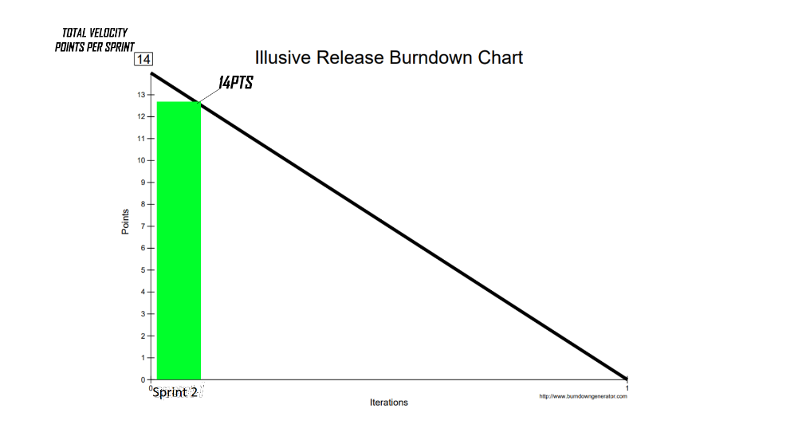

This is the upadted release plan after sprint 1 has been completed



**The revised team velocity and how it was calculated**

We calculated each velocity point for each user story by meeting as a team and each member wrote what amount of velocity points each user story should have and we put them all together and averaged them out. Below you can see our sprint 2 scrum board and each user story has the velocity points beside them adding up to a total of 14.

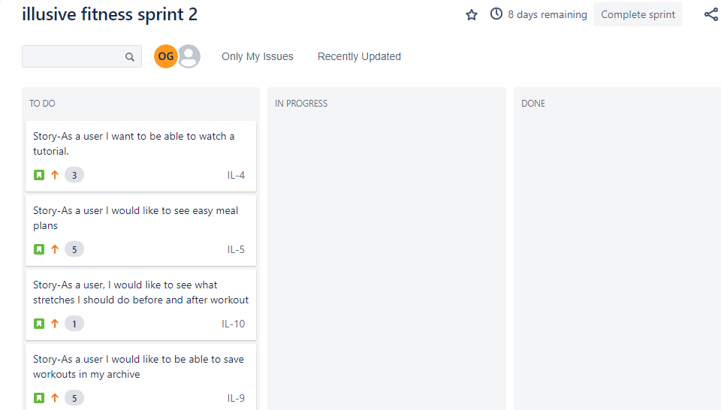

**Brought forward corrective stories from the retrospective at the end of sprint 1**

After sprint 1 we did not have to bring any corrective stories the development team got all the code done in time and fit all the user stories into the project in time.

**Before Sprint 2 Begins**

Before sprint 2 begins we have had meetings in class and an hour before class we have a big A3 size sheet stuck up on the wall which we have many user stories stuck to it and we have just discussed how we will approach sprint 2. We have already completed sprint 1 so we have learned some things already. Sprint 1 went okay we did not have any major problems, and everything was finished on time. So, we are hoping sprint 2 goes the same. We have our sprint 2 set up on Jira also just as Sprint 1 was.